1. Summary

The Data Warehouse and Business Intelligence (DW/BI) testing project aimed to verify the accuracy and performance of the ETL pipelines and reporting layers. Our team conducted a comprehensive evaluation of the data migration, transformation, and visualization logic across the DW system.

Testing activities ensured that data integrity was maintained from source systems to final reporting. We discovered several issues, mostly related to incorrect data mappings, missing transformations, and performance delays in scheduled report queries.

Overall, 89% of all test cases passed successfully. Critical and high-severity defects were addressed and resolved during the test cycle.

2. Test Team

| Name | Role |
| --- | --- |
| Anna Ivanova | Test Lead |
| Mikheil Kapanadze | Data QA Engineer |
| Ketevan Bakradze | BI Analyst |
| Irakli Giorgadze | Developer (ETL) |

3. Testing Process Description

Testing included the following phases:

3.1. Data Validation

* Source-to-target comparisons were made using SQL queries.
* Null checks, duplicates, and truncation validations were conducted on target tables.

3.2. ETL Logic Validation

* Validated business rules and calculated fields (e.g., revenue aggregations, discounts, and transformation logic).
* Detected mismatch in client segmentation mapping, later fixed by the development team.

3.3. Report Verification

* Verified KPIs, filters, grouping levels, and dynamic date ranges.
* Found discrepancies in the “Monthly Revenue” and “Customer Churn” reports.

3.4. Performance Testing

* Load test simulated 100 concurrent users accessing dashboards.
* Found performance lag in the sales dashboard; issue mitigated by indexing and query optimization.

**4. New Defects Statistics**

| **Severity** | **Count** |
| --- | --- |
| Critical | 2 |
| High | 4 |
| Medium | 6 |
| Low | 5 |

Total New Defects: 17

5. New Defects List

| ID | Description | Severity | Status |
| --- | --- | --- | --- |
| DQ-101 | Nulls in Client Segments after ETL | Critical | Fixed |
| DQ-104 | Report filters not working for Q1 data | High | Fixed |
| DQ-106 | Missing customer churn logic | High | Fixed |
| DQ-109 | Sales report delayed by 20 seconds | Medium | Fixed |
| DQ-113 | Country code truncated in customer dim | Medium | Fixed |
| DQ-117 | Extra whitespace in product names | Low | Accepted |

6. Recommendations

* Add additional validation rules for segmentation and category mappings.
* Conduct nightly regression testing for daily jobs.
* Review business rules regularly with BI team before deployment.
* Set up automated alerting on slow query detection.

7. Attachments (Visualizations)

1. New Defects by Severity:

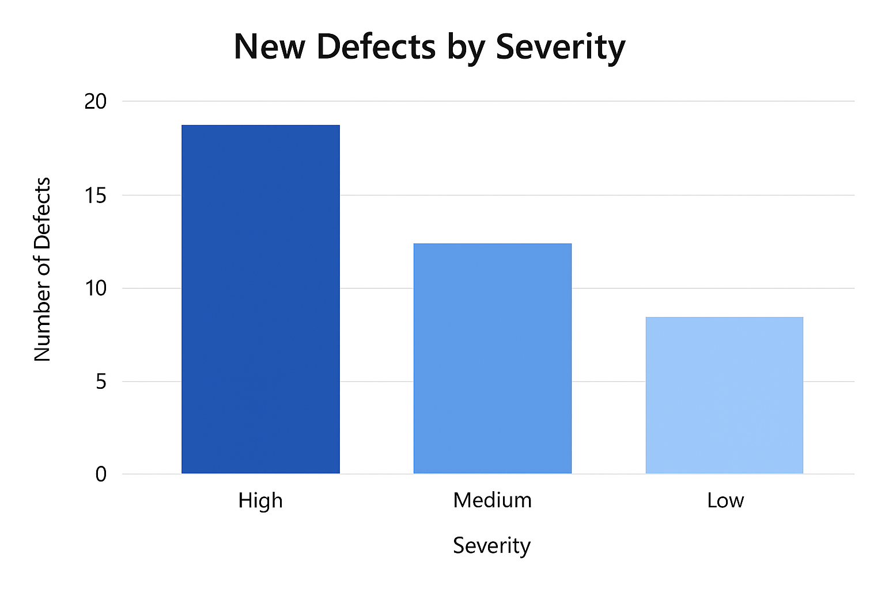

1. Testing Progress:

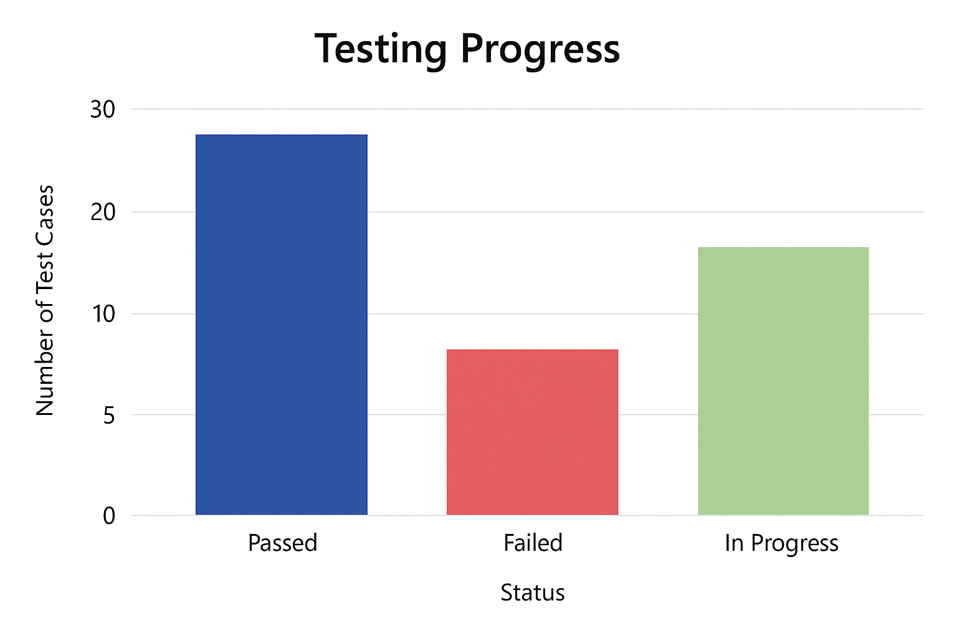

1. Defects by Category